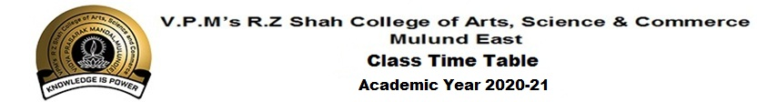
Class: SY CS
DAY  TIME | MON | TUE | WED | THU | FRI | SAT
9:00-9:30 | NIS  OS | ANC  WEB |  | PALL  DBMS | VIL  ToC | SWA  IoT
9:30-9:40 | Break
9:40-10:10 | VIL  ToC | PALL  DBMS | NIS  OS | ANC  WEB | ANC  WEB | GAU  MATHS
10:10-10:20 | Break
10:20-10:50 | PALL  DBMS | SWA  IoT | GAU  MATHS | SAMP  JAVA | SWA  IoT | SAMP  JAVA
10:50-11:00 | Break
11:00-11:30 | GAU  MATHS | SAMP  JAVA | VIL  ToC |  |  | NIS  OS

S.No. | Name of the Subject | Name of the Faculty
1 | Theory of Computation | Mr.Vilas M
2 | Core Java | Ms.Sampurna S
3 | Operating System | Ms.Nisha K
4 | Database Management Systems | Ms.Pallavi W
5 | Combinatorics & Graph Theory | Ms.Gauri A
6 | Physical Computing & IoT Programming | Ms.Swara P
7 | Web Programming | Ms.Anita C

Julie Jenita G Dr.B.S.Ajithkumar
Convenor Principal
Time Table Committee

