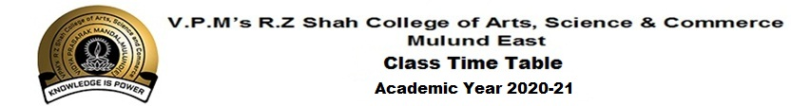Class : SY BMS
DAY  TIME | MON | TUE | WED | THU | FRI | SAT
9:00-9:30 | SHRU | LAK | LAK | LAK | VIJI | VIJI
9:40-10:10 | ANC | SUBH | SUBH | VIJI | SHRU | LAK
10:20-10:50 | NAN(HR) | ANC | PRA(HR) | SUBH | SAMP | SHRU
11:00-11:30 | VIJI(HR)  PRA(M) | PRA(M) | NAN(HR)  PRA(M) | SAMP | VIJI(HR) | NAN(HR)  PRA(M)
11:40-12:10 |  | VIJI | SHRU | PRA(HR) |  | SUBH

S.No. | Name of the subject | Name of the Faculty
1 | Business Planning &Entrepreneurial Management | Ms.Shruti Shouche
2 | Environmental Management | Mr.Subhash K
3 | Information Technology in Management - I | Ms.Anita C & Ms.Sampurna S
4 | Accounting for Managerial Decisions | Ms.Laxmi S
5 | Strategic Management | Ms.Vijayalaxmi K
Marketing Group - Electives
6 | Consumer Behaviour (M) | Ms.Ishita S
7 | Advertising(M) | Ms.Pratibha J
Human ResourceGroup - Electives
6 | Recruitment & Selection(HR) | Ms.Nandini S (3L) & Ms.Ishita S (1L)
7 | Employees Relation Welfare(HR) | Ms.Pratibha J (2L) & Ms.Vijayalaxmi K

Dr.Reshma Anvekar Dr.B.S.Ajith Kumar
Time Table Committee Principal

