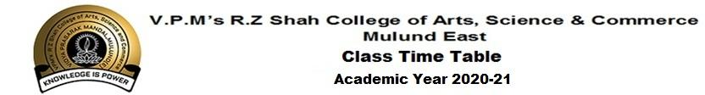
CLASS:SYBA
 | MONDAY | TUESDAY | WEDNESDAY | THURSDAY | FRIDAY | SATURDAY
9:00-9:30 | HIST-III  MANG | HIST-III  MANG | ECO  RESH | PS-II  LAX | FC  JOJI | HIST-II  LAX
9.30-9.40 | BREAK
9:40-10:10 | ECO  RESH | PS-II  LAX | FC  JOJI | ADV  SHRU | PST-II  LAX | FC  JOJI
10.10-10.20 | BREAK
10:20-10.50 | PS-III  KAV | ADV  SHRU | HIST-II  LAX | PS-III  KAV | PS-III  KAV | HIST-III  MANG
10.50-11.00 | BREAK
11:00-11.30 | HIST-II  LAX | ECO  RESH | ADV  SHRU | ECO  RESH | ECO  RESH | ECO  RESH

Faculties and Subject:
- Political Science-III Mrs. Kavita Sharma
- Political Science-II Mr. Laxman Pattar
- Foundation Course Mr. Joji John
- Advertising Mrs. Shruti Shouche
- History-II Mr. Laxman Pattar
- History-III Mr. Mangesh Sawant
- Indian Economy Mrs. Reshma Anvekar
- Macro Economics Mrs. Reshma Anvekar

